

**MMU 420**

**FINITE ELEMENT ANALYSIS**

**FINAL TAKE HOME QUESTION**

Prepared : Gökay KART / 21832009

Course Manager : Assist. Prof. Dr. Mehmet Nurullah Balcı

First, we defined the materials.

tablo içeren bir resim

Açıklama otomatik olarak oluşturuldu

Figure 1 : Structural Steel

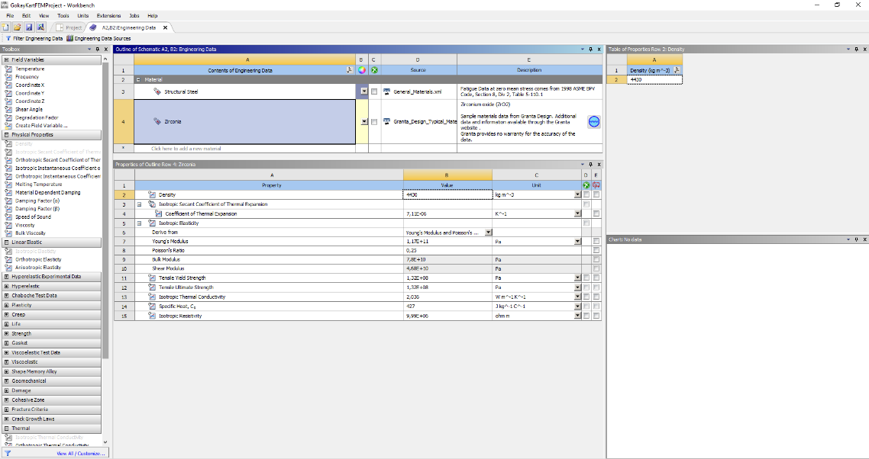

Figure 2 : ZrO2

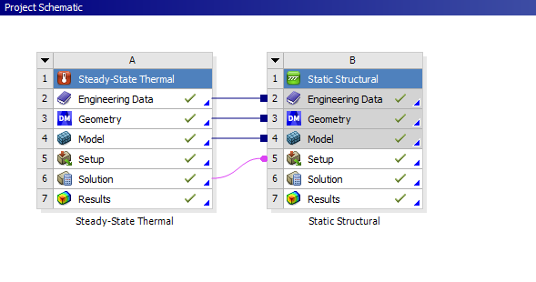

Figure 3: Project Page Screenshoot

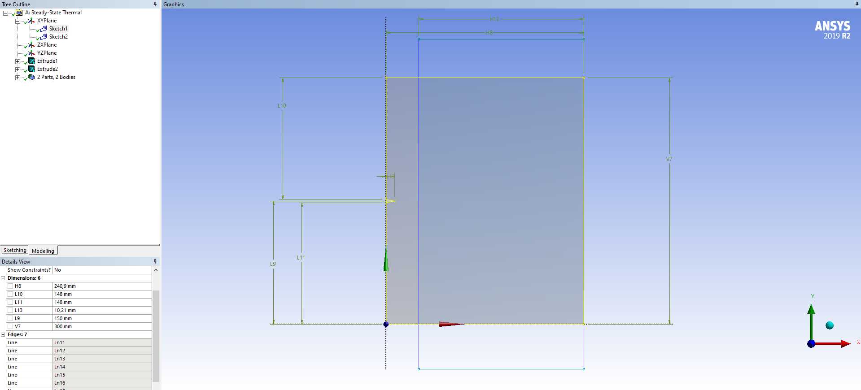

Figure 5 : Bodies and Dimensions

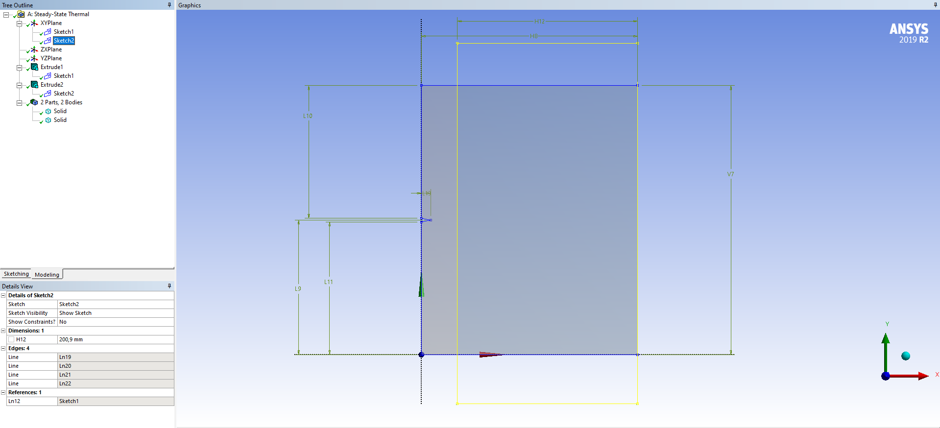

Figure 6: The slice operation I made to divide it into two bodies according to the

dimensions in the question.

We set the track in two parts.

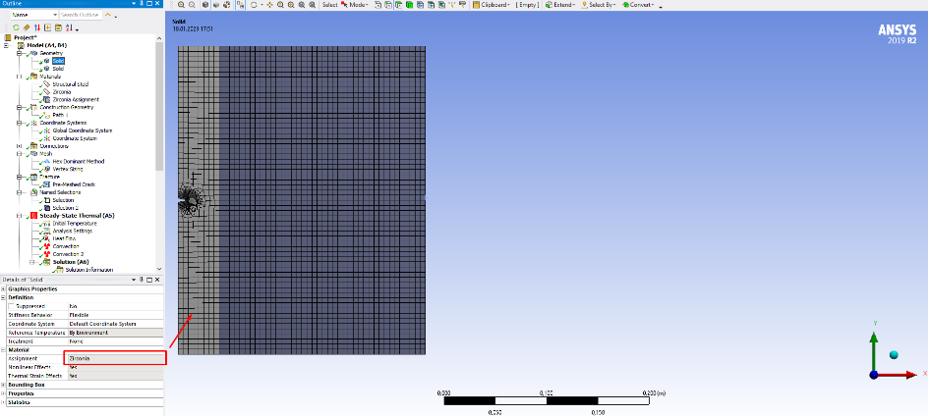

Figure 7 : Convection for tc

tablo içeren bir resim

Açıklama otomatik olarak oluşturuldu

Figure 8 : Convection for tl

Project part is as shown below.

tablo içeren bir resim

Açıklama otomatik olarak oluşturuldu

Figure 9 : Project Table

The given key features are processed as shown below.

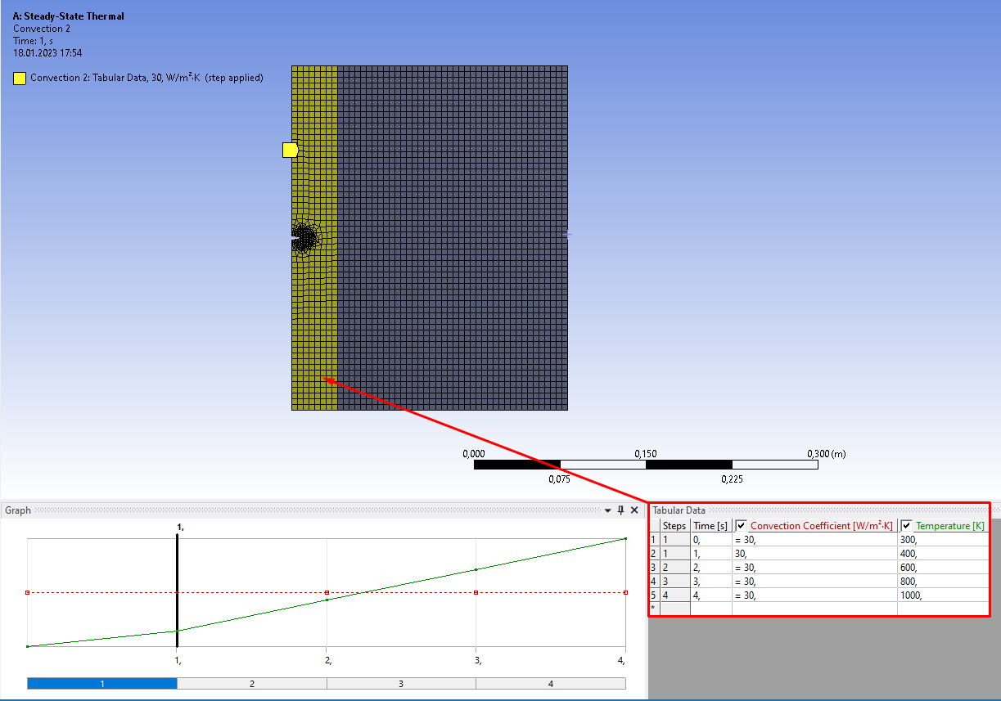

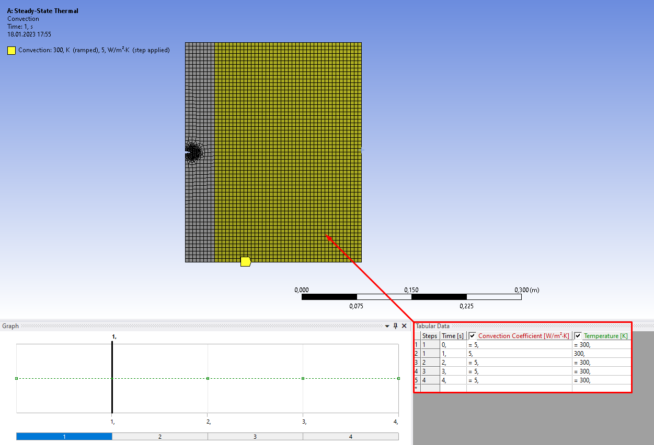

**RESULTS**

1. Plot the equivalent von-Mises stress distribution on the path defined from (a ,L/2) to (tc + tl/2,L/2) at T0 = 300, 400, 600, 800, 1000 K on the same graph. Give some contour plots for temperature field.

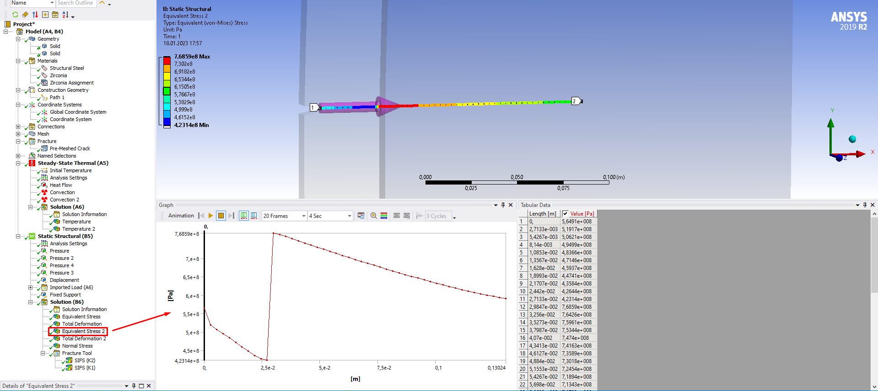

Figure 10 : Section of a answer

Results for thermal properties;

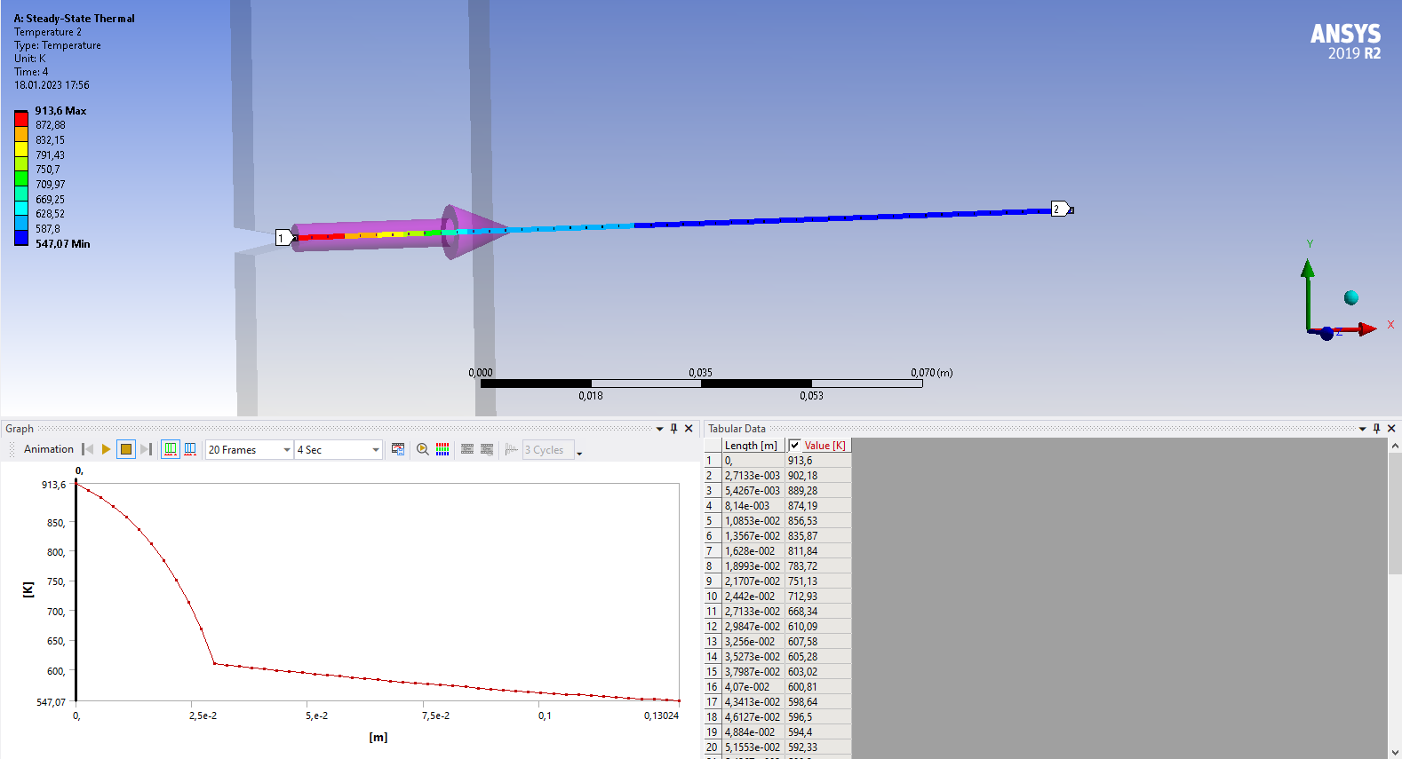

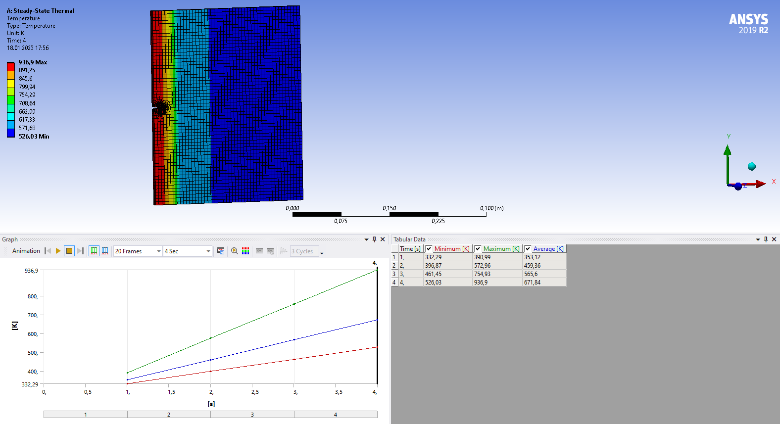

1. Plot the mode-I and mode-II stress intensity factor KI and KII (MPa√m) with respect to T0 where T0 = {300, 400, 500, 600, … ,1000} K on the same graph. Give some contour plots for von-Mises stress plot.

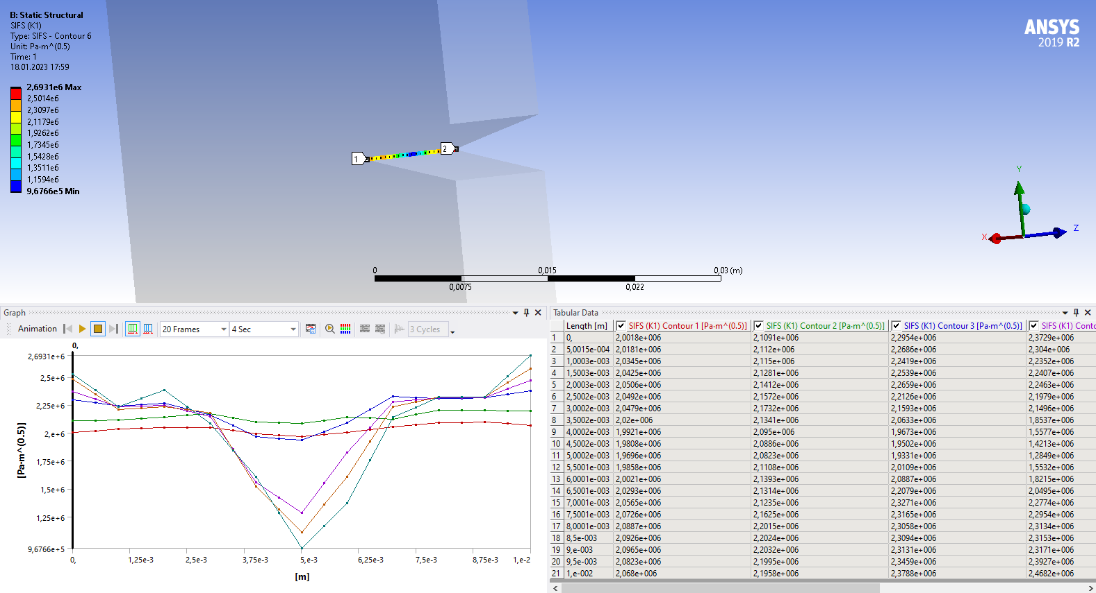

Figure : Section of b answer for K1

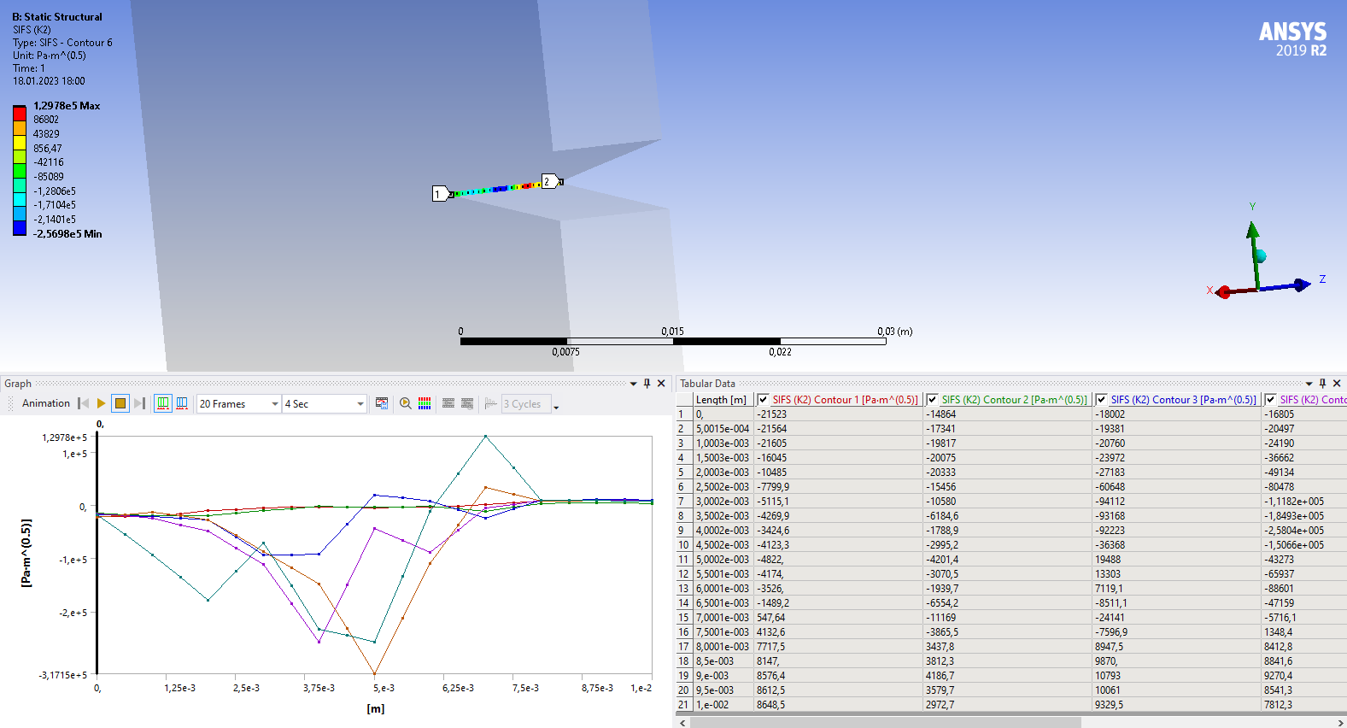

Figure : Section of b answer for K1